J METER API STRESS TESTING
Flight Booking System Using Reactive Mongo DB

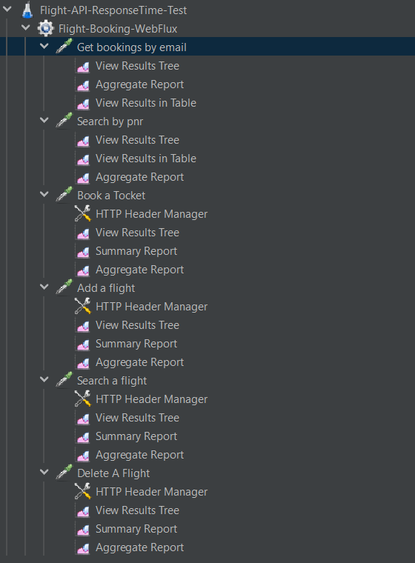

Get Bookings by email
GET -http://localhost:8051/api/v1.0/flight/booking/history/soham@example.com
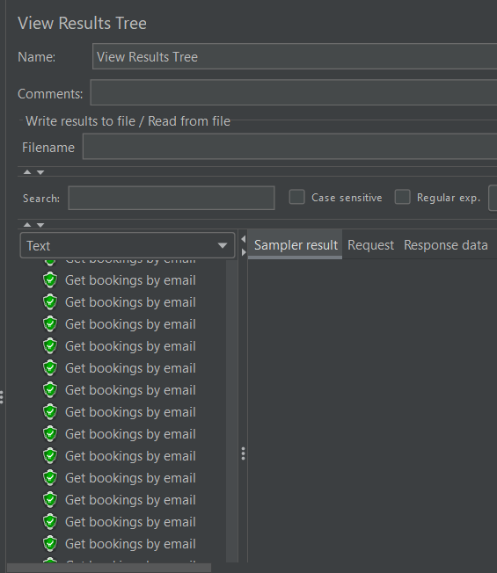
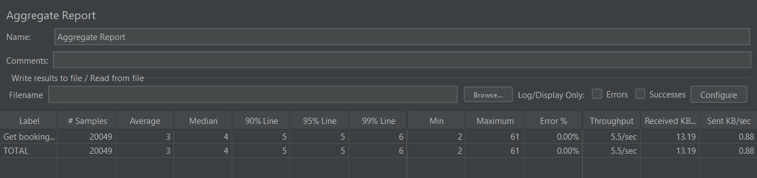

Search By Pnr
GET-
http://localhost:8051/api/v1.0/flight/ticket/{{pnr}}
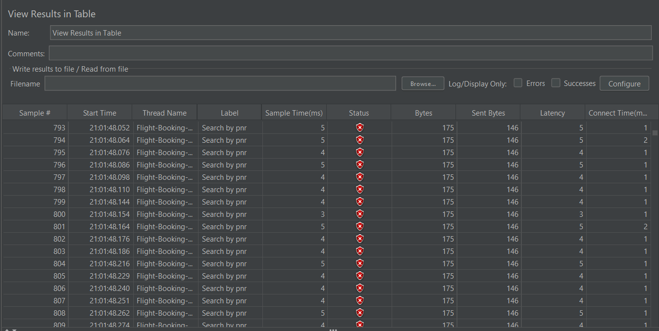
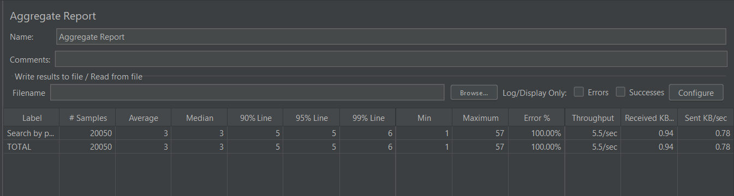

POST - http://localhost:8051/api/v1.0/flight/booking/{{flightId}}
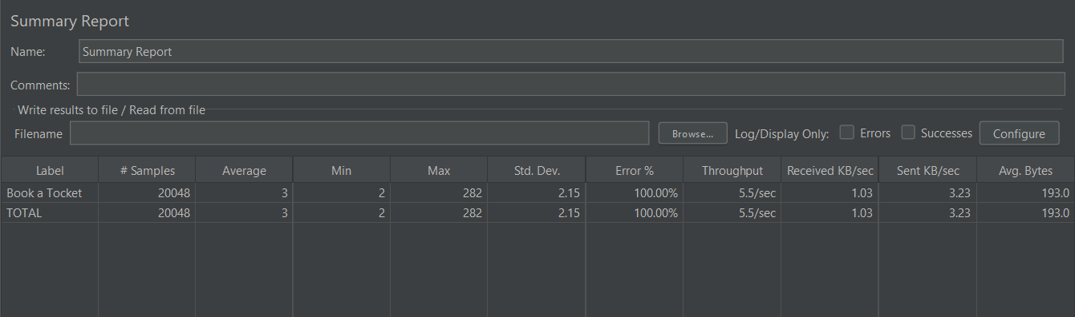
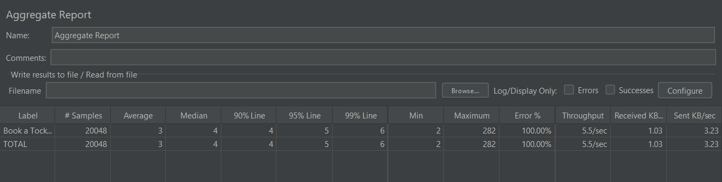

POST -http://localhost:8051/api/v1.0/flight/airline/inventory/IG1
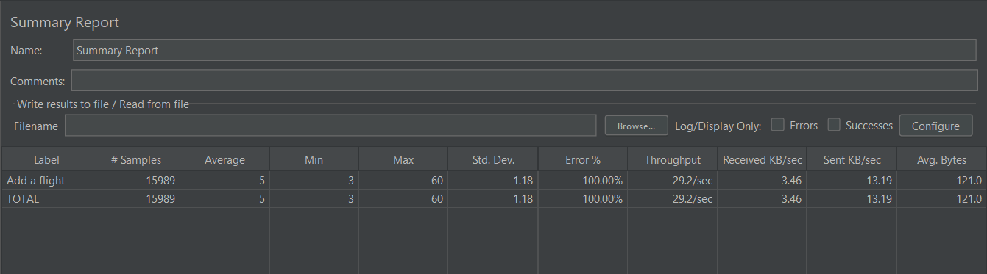
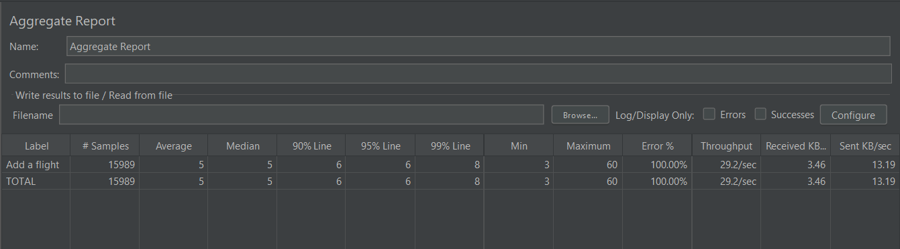

POST -http://localhost:8051/api/v1.0/flight/search
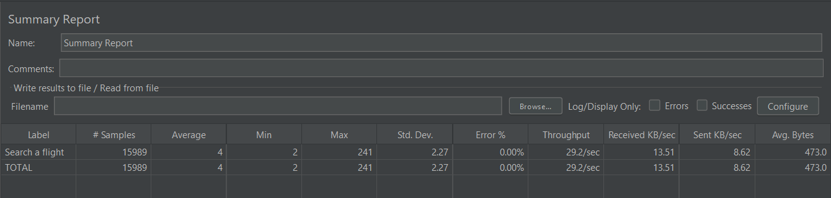

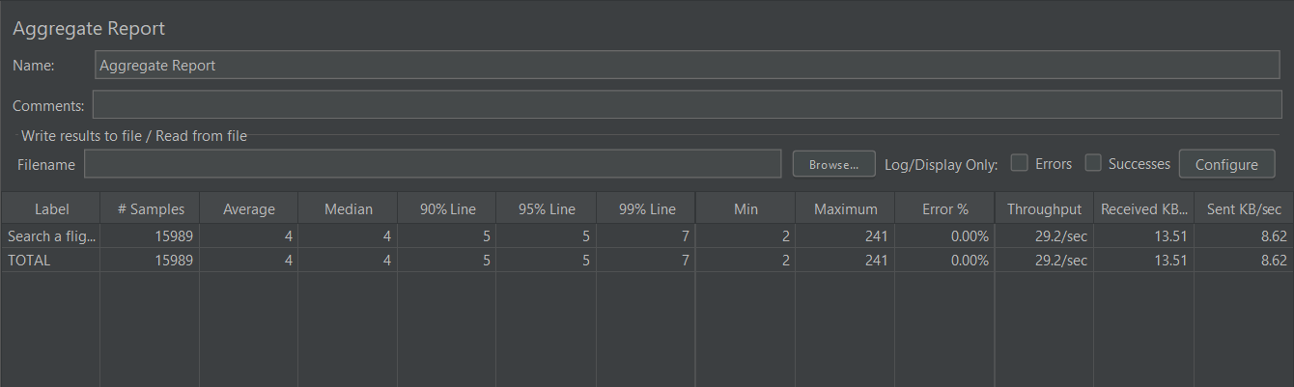

DELETE -http://localhost:8051/api/v1.0/flight/booking/cancel/{{pnr}}
